Please circulate!

AFRICAN CRITICAL INQUIRY PROGRAMME

“Who defines the needs of the people and the related
epistemologies that serve them?” (Karp & Masolo 2000:10)
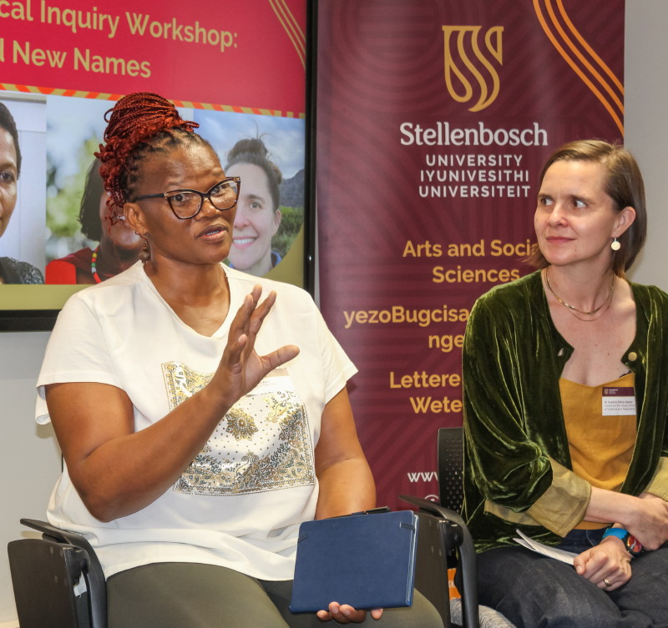
Thozama April (left), one of the organisers of We Need New Names, the 2025 ACIP
Workshop, makes a point as co-organiser Sophia Sanan looks on. Photo by Jesse Le Roux.

CALL FOR APPLICATIONS
IVAN KARP DOCTORAL RESEARCH AWARDS
FOR AFRICAN STUDENTS ENROLLED IN
SOUTH AFRICAN Ph.D. PROGRAMMES
Closing Date: Friday 1 May 2026

The African Critical Inquiry Programme is pleased to announce the 2026 Ivan Karp Doctoral Research Awards to support African doctoral students in the humanities and humanistic social sciences who are enrolled at South African universities and conducting dissertation research on relevant topics. Grant amounts vary depending on research plans, with a maximum award of ZAR 50,000.

The African Critical Inquiry Programme (ACIP) seeks to advance inquiry and debate about the roles and practice of public culture, public cultural institutions, and public scholarship in shaping identities and society in Africa. The ACIP is committed to collaboration between scholars and the makers of culture/history, and to fostering inquiry into the politics of knowledge production, the relationships between the colonial/apartheid and the postcolonial/postapartheid, and the importance of critical pluralism as against nationalist discourse. ACIP is a partnership between the Centre for Humanities Research at the University of the Western Cape and the Laney Graduate School of Emory University in Atlanta, Georgia (USA).

ELIGIBILITY: The Ivan Karp Doctoral Research Awards are open to African postgraduate students (regardless of citizenship) in the humanities and humanistic social sciences. Applicants must be currently registered in a Ph.D. programme in a South African university and be working on topics related to ACIP’s focus. Awards will support doctoral research projects focused on topics such as institutions of public culture, particular aspects of museums and exhibitions, forms and practices of public scholarship, culture and communication, and the theories, histories, and systems of thought that shape and illuminate public culture and public scholarship. Applicants must have a dissertation proposal that has been submitted and approved by their institution to confirm the award; this must be completed before they begin ACIP-supported on-site research or by December 2026, whichever comes first.

APPLICATION PROCESS: Awards are open to proposals working with a range of methodologies in the humanities and humanistic social sciences, including research in archives and collections, fieldwork, interviews, surveys, and quantitative data collection. Applicants are expected to write in clear, intelligible prose for a selection committee that is multi-disciplinary and cross-regional. Proposals should show thorough knowledge of the major concepts, theories, and methods in the applicant's discipline and in other related fields and include a bibliography relevant to the research. Applicants should specify why an extended period of on-site research is essential to successfully complete the proposed doctoral dissertation. Applicants are urged to consult the guidance and advice on how to write a good proposal and prepare a well-crafted budget found in the Resources section of the ACIP website (https://gs.emory.edu/guides/students/acip.html) or here: http://www.ssrc.org/publications/view/the-art-of-writing-proposals/.

To apply, eligible applicants should submit the following as a single file attachment with documents in the order listed:

- completed cover sheet (form below and online at the end of application information at https://gs.emory.edu/guides/students/acip.html, under ACIP Opportunities)
- abstract of the proposed research project (250 words maximum)
- research proposal outlining the project’s goals, central questions, significance, and relevance for ACIP’s concerns. Proposals should include a clear, specific research design and plan of work (specify and justify sources, methods of data collection and analysis as applied in your project, and how they allow you to answer your research question). Applicants should provide evidence of appropriate training to undertake the proposed research, including any language fluency needed. Proposals should be no longer than 1800 words; they should be double spaced, with 2.5 cm margins and a font no smaller than 11 point. Applications that do not follow these format guidelines will not be considered.
- bibliography of up to two additional pages (Select citations to include; do not simply stop your list mid-alphabet.)
- project budget listing project expenses to be supported by the award. Your budget should justify items listed and indicate the basis for calculating estimated budget amounts. Do not include vague “contingencies” categories.
- your curriculum vitae
- current academic transcript and proof of registration at your current institution
- two referee letters; one of these must be from your supervisor. Your referees should comment specifically on your proposed project, its quality and significance, and your qualifications for undertaking it. They should also evaluate the strengths and weaknesses of your project and how you and your work would benefit from receiving the research award. Referee letters should be submitted directly to the Selection Committee.

Funding is to be used for on-site dissertation research; research cannot be at the applicant’s home institution unless that institution has necessary site-specific research holdings not otherwise available to the applicant. If your budget includes equipment purchase(s) (e.g., laptop; photo, video, or audio equipment), you must clearly and specifically motivate the request in relation to planned work and successful project completion, show that the request is for cost-effective equipment appropriate to your research that you do not otherwise have access to, and explain what you plan to do with the equipment at the end of your project (e.g. donate to an educational organization related to your research). ACIP will not support equipment requests totaling more than 20% of the budget.

Applicants who have completed significant funded dissertation research by the start of their proposed ACIP research may be ineligible to apply to extend research time. Eligibility will be at the discretion of the ACIP Selection Committee, depending on completed research time and funding. Please note that Ivan Karp Doctoral Research Awards support dissertation research only and may not be used for dissertation write-up, editing or printing; tuition; study at other universities; conference participation; or to reimburse debts or expenses for research already completed. The programme does not accept applications from Ph.D. programmes in Law, Business, Medicine, Nursing, or Journalism, nor does it accept applications from doctoral programmes that do not lead to a Ph.D.

SELECTION PROCESS: Applications will be reviewed by the ACIP Selection Committee, an interdisciplinary group of scholars and practitioners drawn from a range of universities and cultural institutions. Selection will be based on the merit and strength of the application. Award amounts will vary according to project needs; the maximum award is ZAR 50,000. Awards will be made only if applications of high quality are received. Notification of awards will be made by late July.

Successful applicants will be required to attend the African Critical Inquiry Workshop in the following year and will have opportunities to consult with scholars associated with the Workshop. They will be expected to attend subsequent ACIP Workshops while completing their dissertations, if possible. After completing their research, applicants must submit a final research report and a financial report.

Students who receive an Ivan Karp Doctoral Research Award from ACIP must acknowledge the support in their dissertation and in any publications resulting from the research. When the dissertation is completed, they must deposit a copy with the African Critical Inquiry Programme at the Centre for Humanities Research.

Closing date: Applications and referees’ letters must be received on or before Friday 1 May 2026. Incomplete applications and applications that do not conform to format guidelines will not be considered.
Please submit materials as a single file attachment with documents in the order listed above. Applications should be sent by email with the heading “ACIP 2026 Research Award Application” to acip.uwc@gmail.com.

Supported by funding from the Ivan Karp and Corinne Kratz Fund
https://gs.emory.edu/guides/students/acip.html
https://www.facebook.com/ivan.karp.corinne.kratz.fund
AFRICAN CRITICAL INQUIRY PROGRAMME
2026 IVAN KARP DOCTORAL RESEARCH AWARDS
FOR AFRICAN STUDENTS ENROLLED IN
SOUTH AFRICAN Ph.D. PROGRAMMES

To apply for an Ivan Karp Doctoral Research Award, complete this cover sheet and submit it with:

- an abstract of the proposed research project (250 words maximum)
- a research proposal no longer than 1800 words, double spaced, with 2.5 cm margins and font no smaller than 11 point. Applications that do not follow these format guidelines will not be considered.
- a bibliography of up to two additional pages
- a project budget listing expenses to be supported. Your budget should motivate items listed and indicate the basis for calculating amounts requested.
- your curriculum vitae
- current academic transcript and proof of registration at your current institution
- two referee letters should be submitted directly to the Selection Committee by email to acip.uwc@gmail.com. One must be from your supervisor.

Please email your application as a single file with material in the above order to acip.uwc@gmail.com. The closing date for applications is Friday 1 May 2026.

NAME:

EMAIL: PHONE:

MAILING ADDRESS:

NATIONALITY:

ARE YOU CURRENTLY ENROLLED IN A PhD PROGRAMME IN A SOUTH AFRICAN UNIVERSITY (check one)? □ Yes □ No

UNIVERSITY:

PhD PROGRAMME/DEPARTMENT:

YEAR OF STUDY IN THE PROGRAMME:

NAME AND POSITION OF SUPERVISOR:

NAME AND POSITION OF SECOND REFEREE:

TITLE OF RESEARCH PROJECT:

LOCATION OF RESEARCH PROJECT:

TOTAL RESEARCH SUPPORT REQUESTED:

