James Weldon Johnson Institute PhD Completion Fellowship
Guidelines for the 2027-2028 Fellowship Year
Application and General Fellowships Letter of Rec Due: Friday November 20, 2026 (11:59pm)
Established in 2007 to honor the memory and achievements of James Weldon Johnson, the mission of the James Weldon Johnson Institute for the Study of Race and Difference (JWJI) is to support research, teaching, and public dialogue that examine race and intersecting dimensions of human difference including but not limited to class, gender, religion, and sexuality. For additional information about the JWJI, see https://jamesweldonjohnson.emory.edu.
The Johnson Institute is an interdisciplinary institute in the humanities and humanistic social sciences. The Laney Graduate Fellowship supports the completion of a dissertation in any field whose primary subject matter focuses on race and difference.
The fellowship is a completion fellowship, and the fellow is expected to complete their dissertation during the fellowship year. The fellow will receive a 9-month stipend (September - May) along with a 100% subsidy for the Emory University Student Health Insurance Plan (EUSHIP). The health insurance lasts through July. The first stipend payment will be at the end of September, and the final payment will be at the end of May. The current fellowships stipend rate is $31,500 paid over 9 months.

Eligibility
- must be a full-time doctoral student in good standing, both in the Laney Graduate School and in their program
- must be in candidacy during the fellowship.
- must not previously have held an Emory completion fellowship.
- students beyond the fifth year may use the JWJI Fellowship to extend their support.

Responsibilities
- Fellows may be asked to provide some professional development services as appropriate to the needs of the undergraduate fellows and core staff of the Johnson Institute.
- Fellows are required to participate in all programming activities sponsored by the James Weldon Johnson Institute.

Application Materials
(Please ensure all files are in correct orientation, not sideways):
- Curriculum vitae
- Emory transcript (A copy of an unofficial transcript issued to the student is acceptable.)
- Statement of interest regarding working at The James Weldon Johnson Institute for the Study of Race and Difference (2-3pgs max single spaced, not including 3a below).
  - On the final page of your statement, please provide a list of LGS fellowships you are applying for, in order of preference from 1st preference to last.
- 5-10 page writing sample
- Dissertation timeline
- A faculty GENERAL letter of recommendation assessing your abilities and verifying that you are likely to complete your dissertation during the fellowship period (see below).

If this is your first fellowship (non-DTF) application submission in LaneyConnect that requires the LoR: The LaneyConnect system will allow you to select a recommender, and they will receive an email notification of your request. If you already had a general fellowship LoR submitted: the system will populate your application with the previously submitted LoR. Your recommender can only submit the letter once all fellowships in LaneyConnect (only exception is DTF, which has a separate process). This means that your letter writer only needs to write one general letter of support and should not mention any specific fellowship (unless you intend to apply for one fellowship only this year).
Please note that the system will generally take several hours after your submission to send email link to your program administrator. So plan accordingly. All files (including the LoR) must be submitted by the deadline. There will be no exceptions to this policy so ensure that you apply in advance with enough time for the system to generate the email link. We will not accept any applications with missing materials nor accept any materials outside of the system.
- It is the applicant’s responsibility to make sure their recommenders understand the deadline by which they need to submit the LoR once they receive the email link (please make sure they also monitor their spam folder in case their account has a high filtering function).

Person to Submit the General Letter of Recommendation
In the actual application for any applications that require the general LGS Fellowships LoR, the student will see this section:
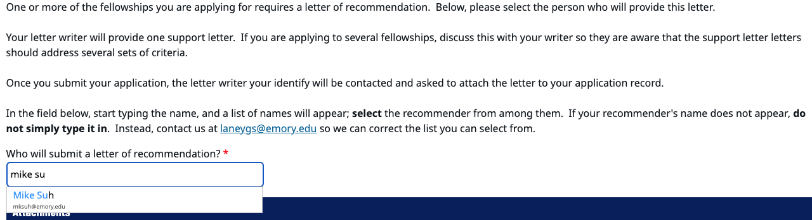

Make sure you start by entering the name (NOT the person’s email) of the person and the system should auto-populate as you begin typing with the person you are looking for. Click the correct person’s name so that the system correctly identifies the person who will receive the link to upload the general fellowships LoR.
Applications that have been submitted cannot be un-submitted. If you selected the wrong person, then it is your responsibility to make sure that person works with the correct person (usually your PA) to upload the letter.

Application Submission
All nominations and applications, including supporting materials, will be uploaded using LaneyConnect: https://laneyconnect.emory.edu/manage/login?realm=&r=/portal/laney-connect-hub.
The portal may not yet be active but when it is activated:
- Select the appropriate fellowship from the list and follow the upload fields. The application will not let you proceed until you upload all the necessary materials. And it will not save incomplete applications so please be sure to have all materials and information ready to upload/complete.
- If you are applying for multiple fellowships, you may select several at one time and submit all materials for the fellowships you intend to apply for (it will not save progress, however, so you must complete your session). Or you may access the portal later and add additional fellowship(s), if eligible, and submit required files for the new fellowship(s) selected (and click “Update” in the online form to complete this process).
In the LaneyConnect application portal, if the applicant has already submitted files that are standard requirements (e.g., transcript), they will not be able to submit it again for a different fellowship. We will not accept different versions to be submitted outside of LaneyConnect. All applications will pull from the already uploaded file and be included in all fellowship application(s) that require the specific file in question. This means that students will submit standard files only once and can focus on documents such as the ‘statement of purpose’ which will be specific for each fellowship that requires this document. If you have questions about using LaneyConnect, please contact us at: LGS.profdev@emory.edu. You will need to upload the application items as PDF files.
PLEASE NOTE: It is the student’s responsibility to submit all the correct files at the time of application submission. Once the application has been submitted, it cannot be un-submitted. Different files will not be accepted separately after-the-fact. There will not be any review of files before the deadline has passed to check for accuracy.

Terms of Fellowship
Fellows who are awarded and accept the fellowship award agree to commit to the course teaching load or the general hours/week and responsibilities as described in the sections above. Fellows who do not uphold the requirements of the fellowship may have the fellowship revoked and may lose their funding and EUSHIP subsidy for the remainder of the fellowship term.
Please note that in cases where there are partner units involved, the fellow is responsible for responding to the fellowship director/coordinator in a timely manner and is expected to fulfill the responsibilities as outlined by the original fellowship call. If the student is unable to communicate and respond in a timely manner or is unable to fulfill those responsibilities, their stipend (and EUSHIP subsidy) may be withheld or the fellowship slot may be removed. In some fellowships, the fellow is expected to begin their role around mid/late-August.
When applicable, this fellowship award replaces other graduate school stipend and scholarship funding* a student may have been scheduled to receive for the fellowship year, and the eligibility for that funding cannot be reserved to be used in a subsequent year.
*This does not apply to smaller awards such as WiNS, Centennial, or ARCS Foundation awards.

All LGS fellows will be required to submit an intake form and an outgoing form as part of this fellowship.
- The first intake form will involve the award letter and student details.
- The second intake form will be provided in Spring of the fellowship year.

Fellows who receive offers for other awards must contact the Laney Graduate School PDCP Office (LGS.profdev@emory.edu) to determine whether the two awards may be held concurrently. Please include with this email full details about the other award you may be inquiring about.
In general, external fellowship awards may not be held concurrently with LGS completion/advanced fellowship awards.

Please note: Unless indicated otherwise, all LGS fellowships require on-site in-person participation and completion. There are no remote options available unless explicitly indicated.

Award Notification
Applicants will be notified by Dec – Jan.
This notification period will also include students who were not selected for the fellowship.

Questions about the JWJI Fellowship?
For specific questions about the JWJI fellowship, contact Dr. Andra Gillespie, JWJI Director, at 404.727.2926 or angille@emory.edu.

Questions about the LGS fellowships application system?
For questions about LaneyConnect, contact LGS.profdev@emory.edu.

